

Pono Energy harvests first crop for renewable jet fuel
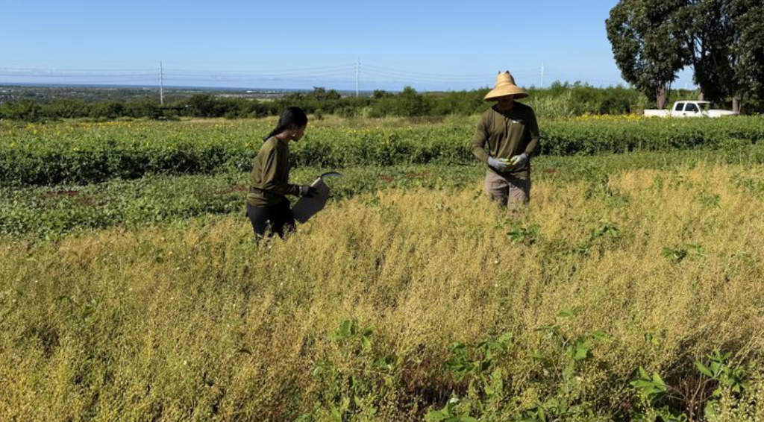
The first of five camelina field trials is harvested through a partnership between Pono Energy and Hawaii Agriculture Research Center.
PONO PACIFIC

By Nichole Villegas – Reporter, Pacific Business News
Jun 16, 2026

Pono Energy, in partnership with Hawaii Agriculture Research Center, this week harvested its first of five camelina trials in Kunia, which will be used to make sustainable fuel for airplanes.
The camelina, a fast-growing oilseed crop in the mustard family, will be used to produce renewable diesel, sustainable aviation fuel and seed cake that can be used for animal feed.

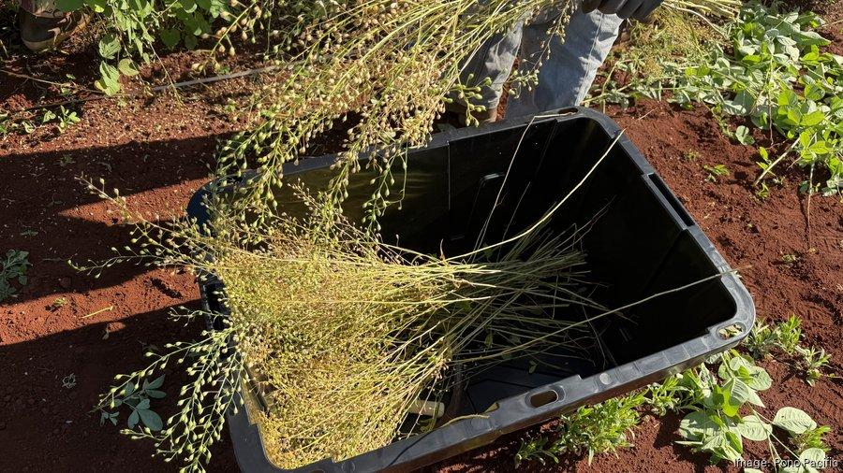
Camelina is a fast-growing oilseed crop in the mustard family, that can be used to produce renewable diesel, sustainable aviation fuel and seed cake that can be used for animal feed.
PONO PACIFIC

The field trials are being done to analyze the best way to commercially grow the camelina crop in Hawaii. To do the trials, Pono Energy was launched earlier this year with a focus on producing renewable fuels derived from camelina. Its sister company is Pono Pacific Land Management LLC, a Hawaii-based natural resource conservation firm. Hawaii Agriculture Research Center owns the land and is contracted by Pono Pacific to conduct the trials.
“Camelina’s low water and fertilizer requirements make it a climate-smart crop well suited to Hawaii’s diverse landscapes," said Dr. Nathan Fumia, lead researcher at HARC. The camelina trial results show an average of 1,250 pounds of seed per acre. In addition to being a sustainable alternative to traditional jet fuel, camelina can be grown in rotation with food crops or on fallow land, which can improve soil health and reduce erosion. The field trials have shown interest from local farmers, ranchers and feed producers.
“We are expanding plot sizes and incorporate mechanized seeding to better evaluate yield potential and move closer to commercial-scale production. Today’s harvest represents an important step toward commercial-scale production, providing the real-world data needed to advance locally grown camelina as a viable renewable fuel feedstock for Hawaii,” Fumia said.

Pono Pacific has also partnered with Par Hawaii since 2023 to develop a consistent supply of locally grown biofuel feedstocks. This year, Par Hawaii will be retrofitting its Kapolei refinery to produce liquid renewable fuels and sustainable aviation fuels — which, compared to jet fuel, can reduce aviation lifecycle carbon emissions by 50% to 80%.
“As a true ‘drop-in’ fuel, camelina-based renewable fuels can be used in existing aircraft, vehicles, and power plants without modification – offering a practical pathway to strengthen Hawaii’s energy independence and food security,” said Pono Energy Vice President, Chris Bennett. “Camelina is a fast-growing cover crop that can be rotated with food crops and produces multiple valuable outputs: oil for renewable fuel, a protein-rich seed meal for aquaculture, livestock and poultry feed, and can even be made into bioplastics thereby supporting a circular, zero-waste agricultural system."
Pono Energy was selected by Elemental Impact in April as one of four startups to receive its first round of investments for 2026.

https://www.bizjournals.com/pacific/news/2026/06/16/pono-energy-camelina-field-trials.html?utm_source=st&utm_medium=en&utm_campaign=me&utm_content=HI&ana=e_HI_me&j=46195505&senddate=2026-06-17&utm_term=ep1&empos=p1

